DApp Development: Wallet Integration
Experiment 2

Aim : Integrating WalletConnect and MetaMask in DApps.

Theory :
To interact with a blockchain like Ethereum or Filecoin, a Decentralized Application (DApp) needs a way to manage user identities, sign transactions, and read on-chain data. This is achieved through wallet providers.

1. MetaMask
MetaMask is the most popular browser extension and mobile wallet for Ethereum and EVM-compatible chains. It acts as a bridge between the browser and the blockchain by injecting a global window.ethereum provider object into the web page.
How it works: When a DApp requests a connection, it calls methods on window.ethereum. MetaMask prompts the user to grant the application access to their public addresses. For state-changing operations, MetaMask will prompt the user to sign the transaction securely.

2. WalletConnect
WalletConnect is an open protocol — not a wallet itself — that enables secure communication between DApps and mobile wallets.
How it works: It uses an end-to-end encrypted connection established either by scanning a QR code (on desktop) or clicking a deep link (on mobile). This allows users to connect their preferred mobile wallet (like Trust Wallet, Rainbow, or the MetaMask mobile app) to a DApp running on a different device or browser securely.

3. Web3 Libraries (ethers.js)
While DApps can interact with the injected provider directly, it is standard practice to use a library like ethers.js or web3.js. These libraries wrap the raw provider (whether from MetaMask or WalletConnect) and offer a developer-friendly API for contract interactions, formatting units, and managing signers.

Code

Prerequisites
First, install the necessary dependencies:
npm install ethers @walletconnect/web3-provider

Integration Implementation
import { ethers } from 'ethers';
import WalletConnectProvider from '@walletconnect/web3-provider';

class WalletIntegrationService {
constructor() {
this.provider = null;
this.signer = null;
this.userAddress = null;
}

/**
* Connect using MetaMask (Injected Provider)
*/
async connectMetaMask() {
if (typeof window.ethereum !== 'undefined') {
try {
// Request account access from MetaMask
await window.ethereum.request({ method: 'eth_requestAccounts' });

// Wrap the injected provider with ethers.js
const browserProvider = new ethers.BrowserProvider(window.ethereum);
this.signer = await browserProvider.getSigner();
this.userAddress = await this.signer.getAddress();
this.provider = browserProvider;

console.log("Connected to MetaMask:", this.userAddress);
return this.userAddress;
} catch (error) {
console.error("MetaMask connection failed:", error);
throw error;
}
} else {
alert("Please install MetaMask!");
throw new Error("MetaMask not found");
}
}

/**
* Connect using WalletConnect
*/
async connectWalletConnect() {
try {
// Configure the WalletConnect Provider
const walletConnectProvider = new WalletConnectProvider({
rpc: {
// Example: Mainnet and testnets (Sepolia / Filecoin Calibration)
1: "https://cloudflare-eth.com/",
314159: "https://api.calibration.node.glif.io/rpc/v1"
},
qrcode: true,
});

// Enable session (triggers QR Code modal)
await walletConnectProvider.enable();

// Wrap the provider with ethers.js (v6 uses BrowserProvider for EIP-1193 providers)
const web3Provider = new ethers.BrowserProvider(walletConnectProvider);
this.signer = await web3Provider.getSigner();
this.userAddress = await this.signer.getAddress();
this.provider = web3Provider;

console.log("Connected via WalletConnect:", this.userAddress);
return this.userAddress;
} catch (error) {
console.error("WalletConnect connection failed:", error);
throw error;
}
}

/**
* Listen for account or network changes
*/
setupEventListeners(callback) {
if (window.ethereum) {
window.ethereum.on('accountsChanged', (accounts) => {
console.log("Account changed:", accounts[0]);
callback(accounts[0]);
});

window.ethereum.on('chainChanged', (chainId) => {
console.log("Network changed. Refreshing page...");
window.location.reload();
});
}
}
}

export default new WalletIntegrationService();

Execution Workflow & Verification
Ask User for Metamask and Github Auth
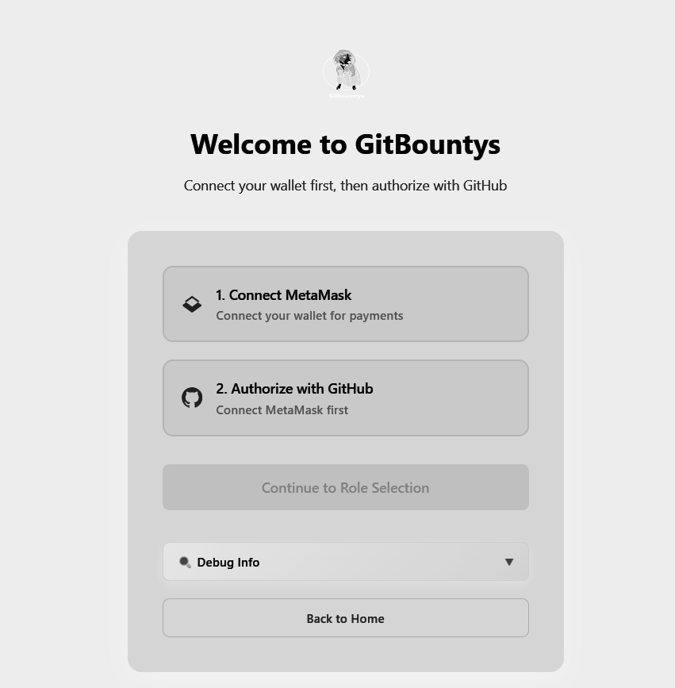

Signature Request on Metamask
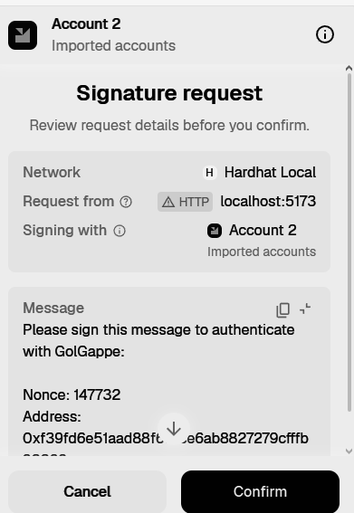

10k ETH in Wallet currently
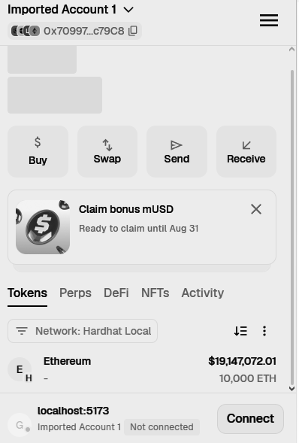

Redeem Bounty
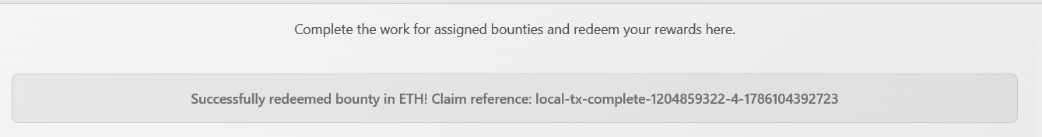

Claimed 100 ETH Bounty
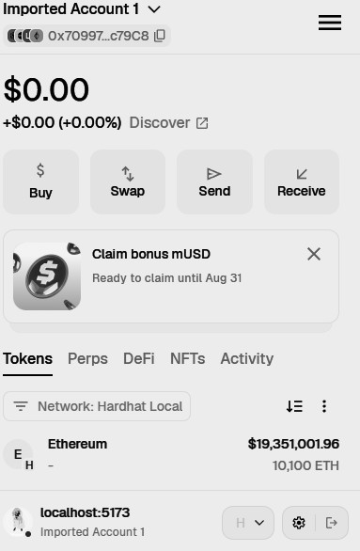

Conclusion
Integrating wallet providers like MetaMask and WalletConnect is a fundamental step in DApp development, serving as the gateway for users to interact with Web3.
By implementing MetaMask, applications cater to desktop users with browser extensions, offering quick and seamless transactions. By supporting WalletConnect, the DApp significantly broadens its accessibility, allowing users to connect a wide variety of mobile wallets securely without needing specialized browser extensions. Using a library like ethers.js abstracts the complexities of these different connection methods into a unified interface, simplifying the process of querying the blockchain and executing smart contract transactions.

